Consent form

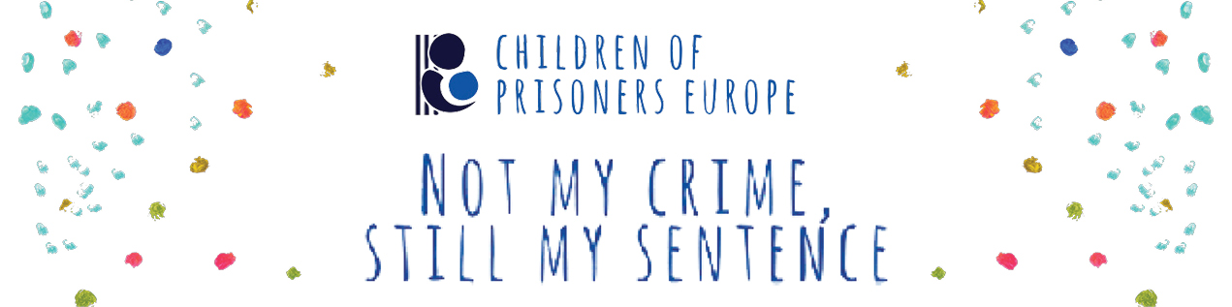
As part of Children of Prisoners Europe (COPE)’s annual “Not my Crime, Still my Sentence” Campaign, your written, artwork or video submission and personal data, including your first and last name, age, city and country of residence, contact details and other information provided within the framework of this campaign are shared with COPE. Only your submission, first name (optional), age and country location will be shared on COPE’s website and social media pages. Your last name and email address will be collected by COPE but will not be shared publicly. This information will only be kept in COPE’s records for the purposes of this campaign and if we need to contact you.

To participate in this project, you have the option, by ticking the relevant boxes below, signing and filling in this consent form, to give your consent that we collect your data and share your written, artwork or video submission and selective data as mentioned above through COPE dissemination and social media channels. By this you give us a free of cost, unlimited licence to use your content/contribution and related information for dissemination on our media channels and website. You confirm that you have the right to the written, artwork or video submission you send, including the consent of all persons recognisable on the video.

We are requesting your consent for the above-mentioned data collection and distribution. If you give your consent, COPE will be able to share your written, artwork or video content/contribution and process your data. Participants should send their content/contributions via the following Google form:
https://forms.gle/pTZdnxSRNZne2Y7c9

You can withdraw your consent at any time by sending an e-mail to contact@networkcope.eu. Withdrawal does not influence the legality of processing your data and using your content before we receive your withdrawal. We will remove all available material and information within a reasonable time after you have withdrawn consent.

COPE’s general privacy notice can be found on the website under Privacy Policy.

I declare that I am more than 13 years old (if not, the name, email and signature of the parent/caretaker is required below)
I consent that the written, artwork or video content I share and the related personal information can be collected and/or used by COPE as stated above in communication activities, including the social media platforms indicated below (your last name and contact details will not be shared on our digital channels or anywhere public).
Facebook
Twitter
COPE webpages
Youtube
Other
I consent that my personal data are transferred to Children of Prisoners Europe for the purpose of the “Not my Crime, Still my Sentence campaign”
Would you like us to feature your first name when releasing the material on our channels? (If YES please tick the box. If NO please leave it blank).
Name: [including the parent/caretaker (legal representative) if applicable]

Email address: [including the parent/caretaker (legal representative) if applicable]

Date:

Signature: [including the parent/caretaker (legal representative) if applicable]

Thank you for your participation!!

