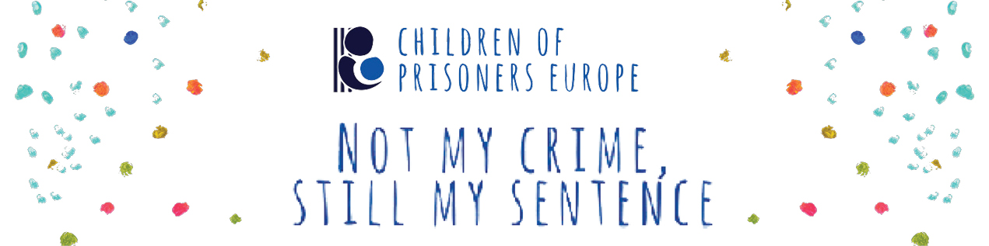
Privacy Statement
for the 2021 “Not my crime, still my sentence” campaign

The protection of your personal data and privacy is important to Children of Prisoners Europe (COPE) and is essential to your participation in the 2021 “Not my crime, still my sentence” campaign. You have the right under EU law to be informed when your personal data is processed [e.g. collected, used, stored] as well as about the purpose and details of that processing.

For the purpose of the 2021 “Not my crime, still my sentence” campaign”, COPE is calling for the participation of children between the ages of 10 and 17. You can find more information on COPE’s campaign webpage: https://childrenofprisoners.eu/campaign-2021/
The campaign will also be promoted through COPE’s social media platforms and by COPE network members. If you are participating in this project, we need your consent to collect and share your written, artwork or video submission on our digital channels, along with your first name (optional), your age, city, and country of residence. Other data, such as your last name and email address will be collected by COPE but will not be shared anywhere public.

What data do we process?
- First and last name of the participant
- City and country of residence
- Age
- Email address
- Information shared by participants and their submission (anything that participants consider relevant for the purpose of the project).

Children of Prisoners Europe will be processing your data and only assigned staff members will have access to your data.

COPE will be using social media to promote this campaign and share your written, artwork or video submission. In addition to the COPE website, videos may be uploaded to the COPE Youtube channel and links may be shared on our Twitter, Facebook or LinkedIn pages. We recommend that users read the Youtube, Twitter, Facebook and LinkedIn privacy policies which explain their data processing policy, use of data, user’s rights and how users can protect their privacy when using these services.

You have a range of rights over your data, which include the right to:
- request access to or a copy of the personal data we hold about you at any time, free of charge;
- the correction of your personal data if incorrect, out of date or incomplete. For example, when you withdraw consent; object and we have no legitimate overriding interest; or once the purpose for which we hold the data has come to an end;
- request a copy of any information that we hold about you at any time and to have that information corrected if it is inaccurate. To ask for your information, please write to us at: contact@networkcope.eu
  - If we choose not to action your request, we will explain the reasons for our refusal;
- withdraw consent
  - Whenever you have given us your consent to use your personal data, you have the right to change your mind at any time and withdraw that consent. At which point, we will remove your information from all our databases and will stop any consent-based processing of your personal data after you withdraw that consent.
If you would like to access the rights listed above, or any other legal rights you have over your data under current legislation, please get in touch with us.

Time limit for keeping the data is 3 years from when the submission is received.

To keep your data secure, the collected personal data are stored safely and are only accessible by assigned staff members. Access to specific files requires authorisation. Measures are provided to prevent unauthorised entities from access, alteration, deletion, disclosure of data. General access to personal data is only possible to recipients with a UserID/Password. Physical copies of personal data are stored in a properly secured manner.

For those who wish to submit a video, we suggest that videos not show faces. Rather, masks can be used or a scene can be recorded that does not include faces.

If you have any questions or concerns you can get in touch with contact@networkcope.eu.

