Submission form

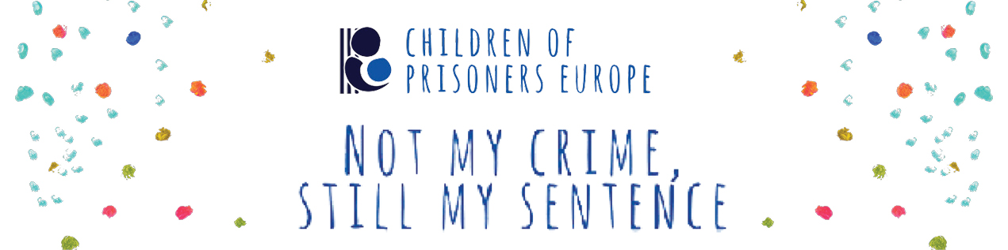
If you do not have a Google account and cannot submit your content for the campaign through the Google form, please fill in this form and send it with your content (written, artwork or video), the written script if you are submitting a video and the consent form through a file transfer service or with email to elia.meschin@networkcope.eu.

* Required

Name and surname of the participant:

_______________________________________________________________

Age:

______________________________

Your city and country:

_______________________________________________________________

Your email address:

_______________________________________________________________

Please provide a suitable title for your submission:

_______________________________________________________________

Would you like to send a short description of your submission?

________________________________________________________________________________________________________________________________________________________________________________________________________________________________________________________________

Thank you for your participation!!

