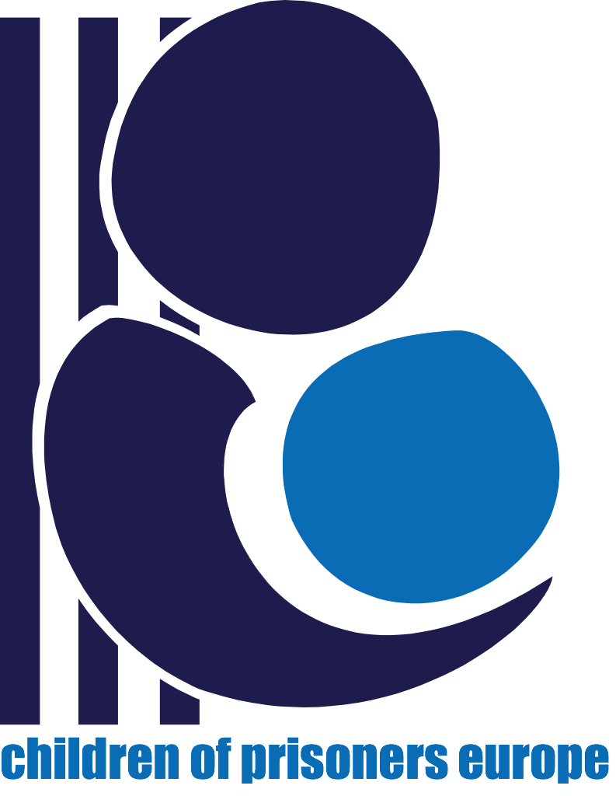


4 October 2024

COPE Input for UN HRC resolution 52/12 – mental health
Children of Prisoners Europe (COPE) welcomes the opportunity to provide input to UN HRC resolution 52/12 – mental health. COPE is an EU-funded network working with and for the estimated 2.1 million children with a parent in prison in Europe. With its 74 member organisations and individuals in 31 Council of Europe countries (and affiliates outside Europe), COPE helps prevent and respond to violations of the rights of children with a parent or family member in prison, while promoting meaningful action to secure their well-being and mental health. COPE's work is elaborated in the COPE Principles. Significantly, COPE was a primary researcher in the milestone EU-funded study Children of prisoners: Interventions and mitigations to strengthen mental health (Jones et al, 2013). Using a mixed-methods multi-sequential research design, the three-year study gathered evidence from over 1,500 children and adults from four European countries to investigate children's mental health needs, examining some of the more subtle dimensions of parental imprisonment, including the meanings that children attribute to the event, the experience of stigma and social isolation that may follow, the family dynamics before, during and after parental imprisonment and any impact these factors may have upon the child’s psychological health and well-being. Children with a parent/carer in prison were found to have a significantly greater risk of mental health problems than children in the general population. This risk is especially great among older children (those aged 11+ years).
More recent literature reviews have examined the link between parental incarceration and the development of externalising and internalising behaviour problems in children (Provencher, 2019). While there is a consensus on the presence of mental health externalising symptoms (e.g., behaviour problems), there are conflicting results regarding the association with internalising symptoms (e.g., anxiety, depression, etc.). Some studies confirm this association (Luk et al., 2022; Poehlmann-Tynan & Turney, 2020; Provencher, 2019; Wildeman et al., 2018), while others do not (Murray et al., 2012). According to Poehlmann-Tynan and Turney’s [2020] and Wildeman et al.’s (2018) reviews, the consequences of parental incarceration manifest in earlier developmental stages for externalising behavioral problems and later for internalising problems. For instance, it has been noted that attention problems and aggression appear between 3 and 5 years of age, while externalising and internalising problems, as well as antisocial behaviours and delinquency, manifest in middle childhood (Poehlmann-Tynan & Turney, 2020). Additionally, recent research has found that more studies have identified children experiencing externalising and internalising behaviour problems at 7 to 11 years of age than in other developmental stages (Herreros-Fraile, Carcedo, Viedma et al., 2023).

The context
A parent’s imprisonment has various impacts on the child. The child's rights to family contact, to develop into healthy adults and to a happy, constructive childhood are often infringed, as are their rights to dignity and equality. In addition to being separated from their parent, children are vulnerable to emotional, physical, academic and financial instability; disruption of the parent-child bond; and discrimination, stigma and violence (e.g., bullying, witnessing a parent’s violent arrest). Meeting their multiple needs involves an array of criminal justice, police, prison, educational and welfare sectors, unique to each country.

These children are a low priority for most governments and not readily recognised as a vulnerable group, despite their exposure to stigma, instability, absence of parental involvement in their upbringing and development, and violence. Few EU countries record data on prisoners’ parental status. Across Europe, service provision levels vary greatly (often nonexistent); great numbers of children are witnessing a parent’s violent arrest; physical or child welfare policies have major gaps; children are not accounted for in sentencing decisions; security concerns prevail over family contact; a great number of people in prison lose contact with their families. A lack of any accurate systematic record of the number of children with parents in prison worldwide is an obstacle to evaluating the number of children impacted with many children falling ‘between the cracks’ due to lack of support. Due to the invisibility of these families, children do not receive proper physical and psychological treatment. These and other obstacles hamper the development of relevant strategies and policy. Children's rights are routinely breached at each stage of adult criminal justice. Child mental health is adversely impacted, with children reported to experience sadness, anxiety, disappointment, guilt, low self-esteem, fear, worries, anger, aggression, crisis, grief, separation anxiety, sleeping problems, bullying and physical reactions to a parent's imprisonment (cf inter alia Fahmy & Berman, 2012). The child’s world becomes one of great uncertainty, particularly during adult criminal justice proceedings and pre-trial detention, when information about the parent’s whereabouts is often lacking. Children grow anxious over concerns about their parent’s health and welfare, associating the more limited contact with them to feelings of abandonment. “Does daddy love me less?” Families often do not know what to do about this situation either and in many cases prefer not to tell the children that their parent is in prison, using alternative explanations such as ‘mum/dad’ is away working. Children can feel that the parents do not love them and that they have chosen a job rather than being with them.
Parental imprisonment is a recognised Adverse Childhood Experience (ACE) and a source of toxic stress, with increased levels of cortisol linked to stress being correlated with reduced lifespans and poor mental health when support is inadequate. Brain architecture development can be adversely impacted, as can other organs and increase the risk for cognitive impairment well into the adult years. Fearing stigma and discrimination, many children don’t speak about their stress, bottling it up instead, and thereby suffer silent stigma and isolation and do not benefit from much-needed support as a result.

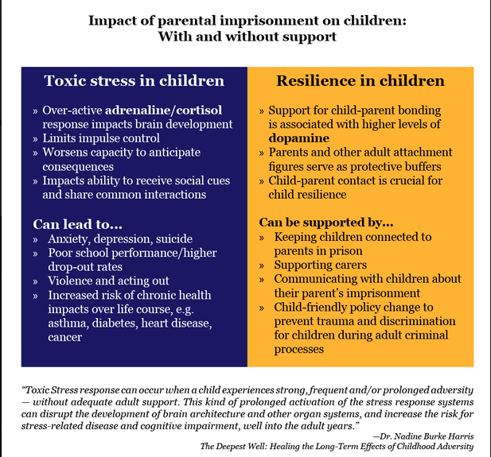

Enabling normative and policy measures for realisation of children's rights
With support, children can build resilience and agency. Having a healthy, stable relationship with a trusted adult has been shown to be a key support for children in general who experience chronic adversity (Masten et al., 1991, cited in Davis & Shlafer, 2017; this holds true for children impacted by parental imprisonment (Jones et al, 2013). Teachers and guidance counsellors in schools can play a key role in supporting children. Schools across South Wales come into prisons to share children's schoolwork with their fathers, enabling school staff to better understand the child's experience, rights and specific needs, while strengthening the father's role as parent. Other cross-sectoral protective factors include stability and routine, with caregivers supported and having access to supports, including financial support to cover additional financial burdens associated with the imprisonment, so caregivers in turn can support children. Spain has developed a Psychological Assistance Service for Children of Incarcerated Parents and their Families (HIPRIFAM), free of charge with specific assistance for caregivers, their children, and also to professionals (teachers, psychologists, social workers, etc.) who work with these families. Better information and open and honest communication about their situation and the parent's whereabouts are key factors, as are respectful media, tolerant communities and efforts to combat stigmatisation. Sensitisation campaigns in schools and targeting society in general showcase how children and families feel during a parent's imprisonment. This type of intervention should reduce the stigma suffered by these children and promote their mental health. Significantly a child’s contact with an imprisoned parent is a known protective factor except if contrary to the child’s best interests; parents must be enabled to participate in children's upbringing and development.

Children need to know about their right to maintain contact with their parent during both pre-trial and sentenced imprisonment as well as their right to non-discrimination, to express their views, to access to information, to protection of identity and privacy, and to have a means to assert their right. Currently, children’s rights are not routinely considered at any stage of the adult criminal justice system. Prison authorities and staff need training on safeguarding children’s rights and well-being when visiting parents in prison, and on how to:
- make prison visits more child-sensitive, physical contact with the parent authorised;
- better support children in often hostile settings and distressing conditions, such as security measures (e.g. searches) that maintain a child’s dignity;
- support imprisoned parents and strengthening the parental role;
- promote quality contact: more frequent phone-calls when the child needs them; more frequent, longer visiting hours and for extended visits. Family Days are organised by prison services in many countries in Europe and worldwide;
- make prison walls more 'permeable', humanising prisons; training prison officers to establish warm, supportive connections with children.
Training and awareness-raising across law enforcement, criminal justice and educational sectors can help systematise support. Integrated child protection systems based on holistic cross-sectoral frameworks with a multidisciplinary approach guaranteeing children's right to justice, civil, political, economic, social and cultural rights need further development. The European Commission promotes a comprehensive approach to mental health as well as its RECOMMENDATION (EU) 2024/1238 of 23 April 2024 on developing and strengthening integrated child protection systems in the best interests of the child. Council of Europe Recommendation CM/Rec(2018)5 strengthens cross-sectoral rights frameworks to help mitigate stressors for children with imprisoned parents. A holistic perspective and approach includes:

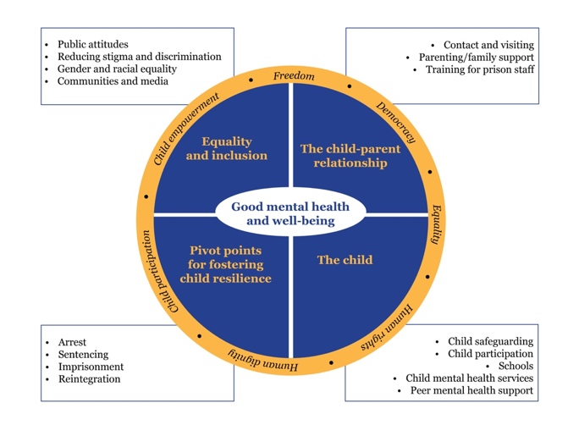

Psychological assistance for children and families, especially for both caregivers and children, is required to help families during prison entry, the imprisonment and reintegration back into communities and homes. Interventions should incorporate the three main actors to protect children’s well-being: children, primary caregivers and parents in prison. Support initiatives for both primary caregivers and parents in prison are also essential in terms of protecting children’s well-being.
Challenges and good practices in implementing enabling normative and policy measures
Barriers to implementing effective change for children include:
· Barriers to information: lack of any accurate systematic record of the number of children with parents in prison worldwide, as well as the lack of information about the realities of prison life, the emotional upheaval experienced by families, the challenges of maintaining contact with incarcerated loved ones, and the strategies for minimising the impact on children and families — all pressing issues that demand urgent attention.
· Structural barriers leading to [often abrupt] separation from the parent, or child, and lack of contact: lack of child-friendly visits in prisons; geographical distance between prisons and families; prisons not considering an individual child’s needs over security issues, e.g. not routinely providing wheelchairs when personal wheelchairs are not allowed.
· Psychological barriers: hostile prison settings and behaviours, strip-searching children prior to visiting parents in prison in some jurisdictions.
Feedback on the OHCHR's Mental Health Guide
Regarding:
Chapter 1: Rethinking Mental Health Legislation
Chapter 2: Legislative Provisions for Rights-Based Systems
Chapter 3: Developing and Implementing Rights-Based Legislation
General assistance to protect mental health in these specific areas for children is lacking, as certain specific needs that require consideration by mental health systems remain unidentified. These include, inter alia, contact with the prison, whether children have been present during a parent's arrest, and stigma. Needs identified by mental health systems in general fail to include the needs of children with a parent in prison as well as those of their families. Due to stigma, families impacted by incarceration usually do not reveal their situation to pediatricians and other professionals; conversely, these professionals generally do not include relevant enquiries as part of their protocols. Consequently, mental health systems are failing to identify those children who are experiencing imprisonment of a parent — even though studies have demonstrated that having a parent in prison is a risk factor that exposes children to physical and mental health difficulties.
With contributions from Dr. Rodrigo J. Carcedo González, Universidad de Salamanca

For conciseness, from now on, we use the term “children” to refer to “children with a parent or family member in prison or in conflict with the law” in this document.

